Eyeconic-Glasses Shop Management System

Add Cloths

Version <1.0>

Revision History

|  |  |  |  |
| --- | --- | --- | --- |
| **Date** | **Version** | **Description** | **Author** |
| <06/11/2019> | <1.0> | creating use case | Nguyễn Tuấn Anh |
|  |  |  |  |

Table of Contents

1. Add Cloths 4

1.1 Brief Description 4

2. Flow of Events 4

2.1 Basic Flow 4

2.2 Exception 4

2.2.1 Add Cloths 4

2.2.2 Fill in the Cloths information 5

3. Special Requirements 5

4. Preconditions 5

4.1 Admin must be logged in 5

5. Postconditions 5

6. Extension Points 5

Use-Case Specification: Add Cloths

# Add Cloths

## Brief Description

This use case defines the step of create/add a new Cloth to the database.

Cloths are added by the admin.

# Flow of Events

## Basic Flow

The system administration clicks a button to add a new item. The administrator fills the information of the new Cloths. The system displays the new Cloths and logs the change.

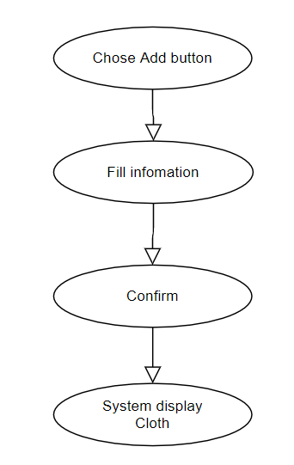

***Basic flow of Adding Cloths***

Step 1: Click the add buttons

The modal view shows up

Step 2: Fill in the Cloths information, name, type, …

Step 3: Confirming adding the Cloths by clicking the “Save” button.

Step 4: Successful added Cloths is displayed to the screen.

## Exception

### Add Cloths

The add button cannot be clicked or isn’t appeared on the screen

### Fill in the Cloths information

Invalid information.

Must fill out all the information in the form.

2.2.3 Confirming adding the Cloths

The “Save” button is clicked but the new Cloths are not added to the database.

This new Cloths are existed in the database.

2.2.4 System displays added Cloths

The added Cloths is not display correctly

# Special Requirements

No Special Requirements

# Preconditions

* User must already login as the administrator of the website
* The added Cloths had not existed in the database before.

# Postconditions

Cloths are created, shown on the screen can be purchased by customers.

# Extension Points

Administrator check the website and the system to ensure that the Cloths is added to the database and display on the screen.